**Yantra Script Results - Fixed Port Out**

**Test Case – 01**

**Script Name:** Fixed Port Ou**t**

**Scenario:** Disconnect

**Order Id:** EOVFXDPRTOUT1oid1715856438768

**Episode Id:** AK451715856462353

**Yantra Script:**

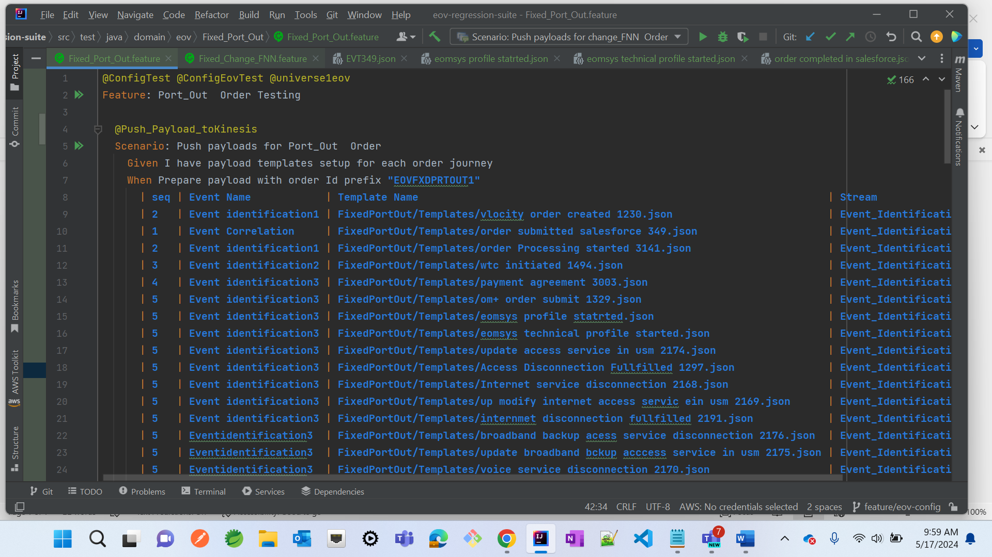

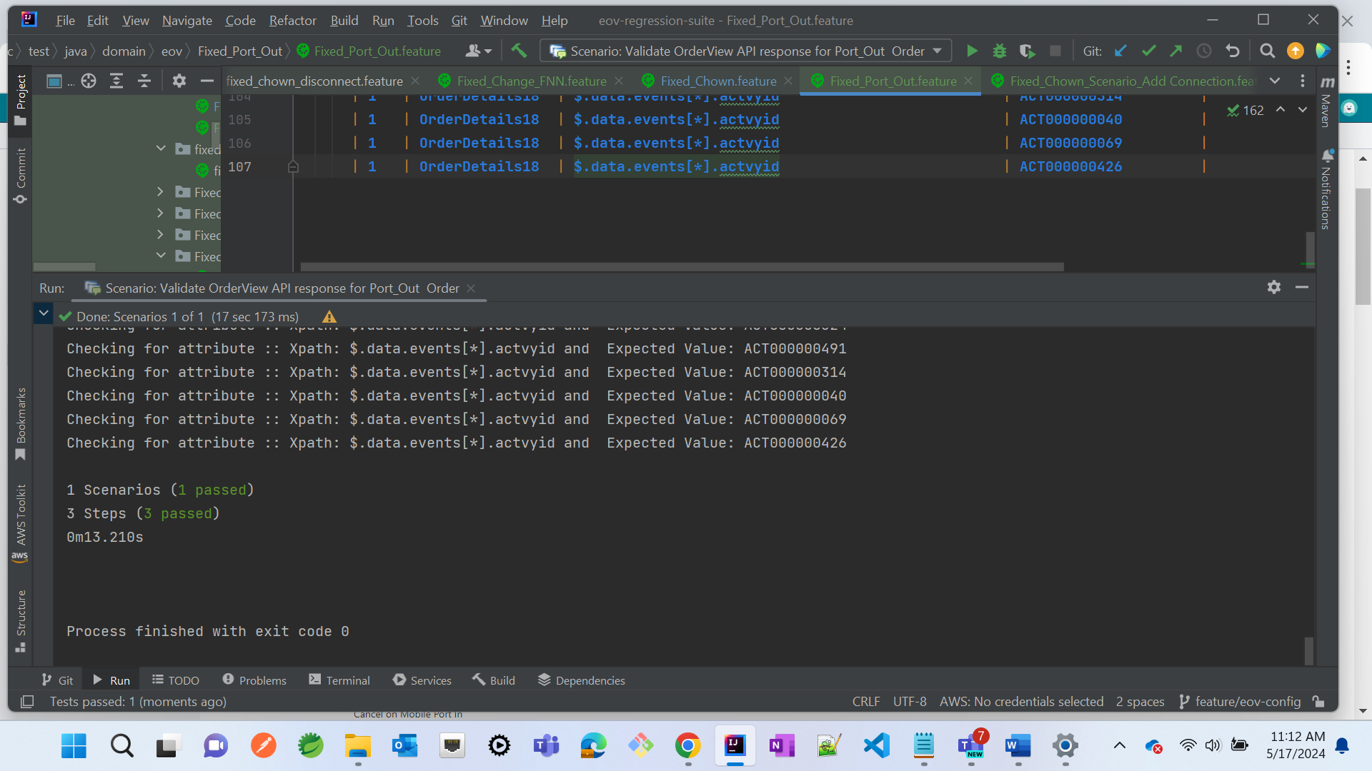

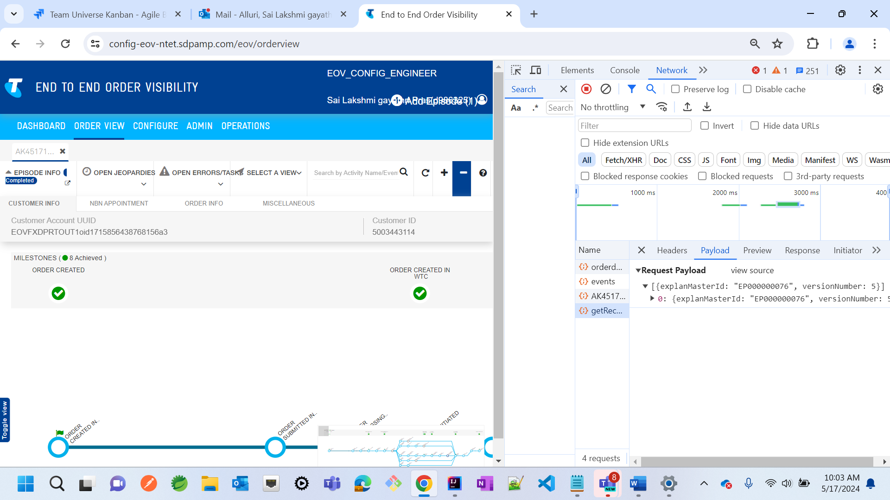

**Test Case -02**

**Script Name:** Fixed_port_out_Scenario_Disconnect Connection

**Scenario:** Disconnect Connection

**Order Id:** EOVFXDPRTOUT2EOVFXDPRTOUT2oid1715925375689

**Episode Id:** CQ991715925402766

**Yantra Script:**

